Use Expression
Step 1:
Create the report. Tutorial 1
Step 2:
The design view is now
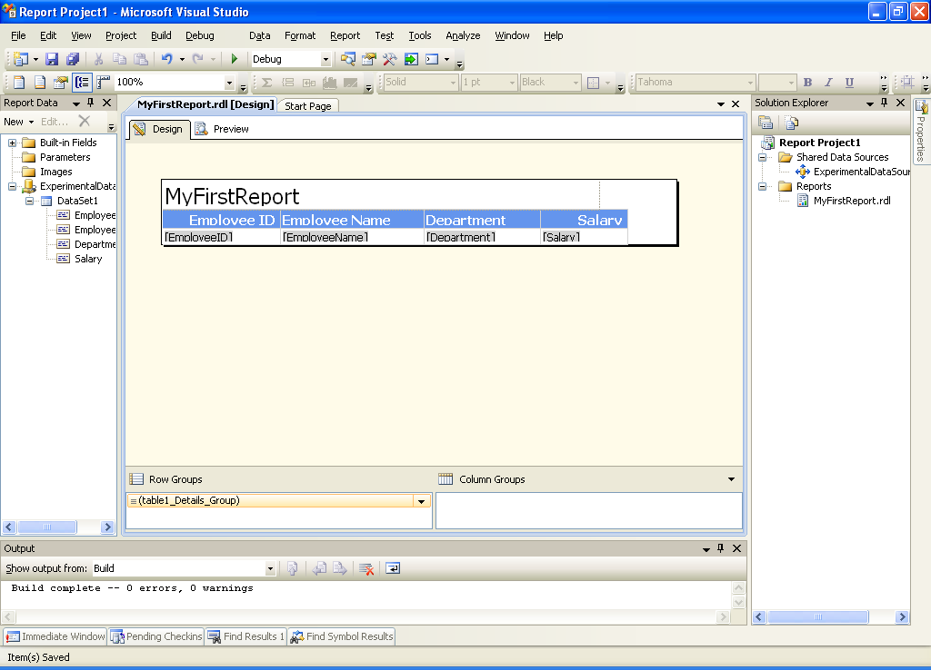
Step 3:
Right click on the report body and choose Report Properties
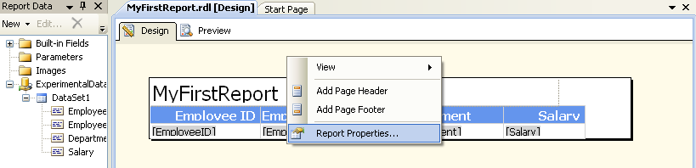

Step 4: Navigate to the Code tab
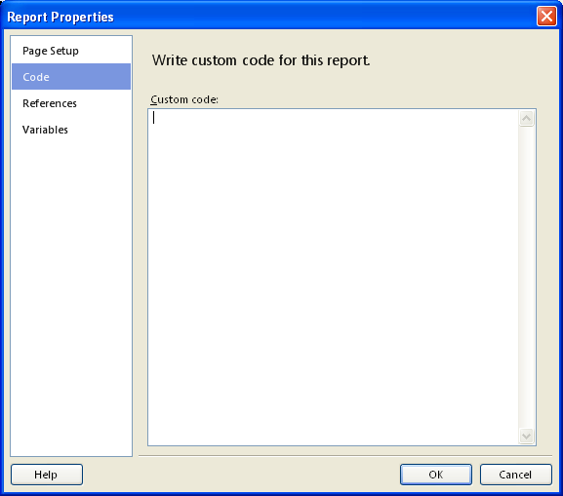
Step 5:
Add the code
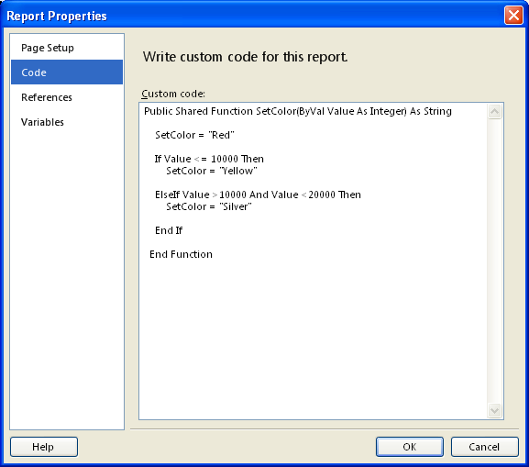
Step 6:
Choose Salary Field and Right Click. Choose TextBox Property
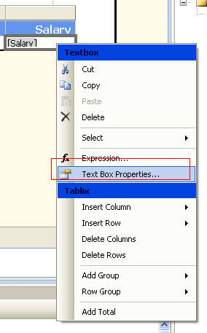

Step 7: Click on the Fill option and click the fx Button.
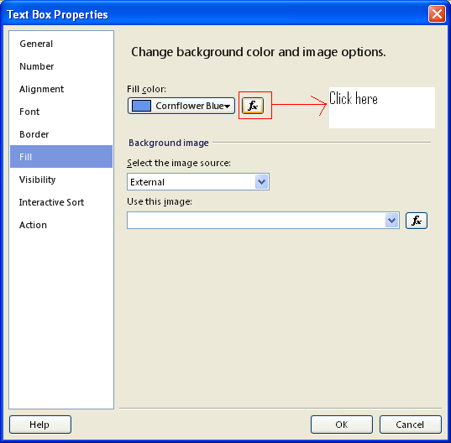
Step 8: Enter the below expression
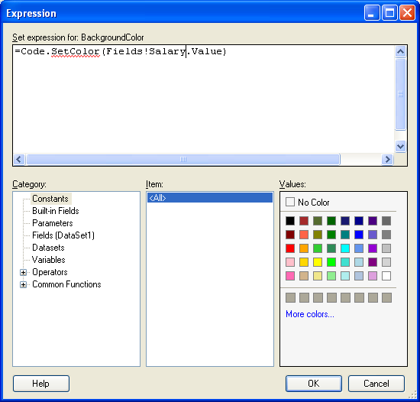
Step 9: Click OK. Save and click on the preview tab.
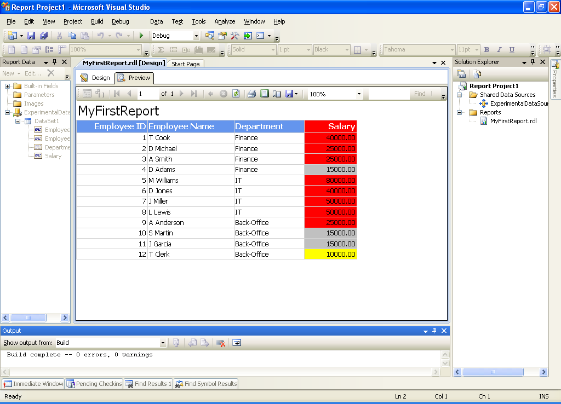
Step 10: Same thing is applicable for any other column
Step 11: More than 1 function can be written. For example say, based on department name, the Font weight will be changed
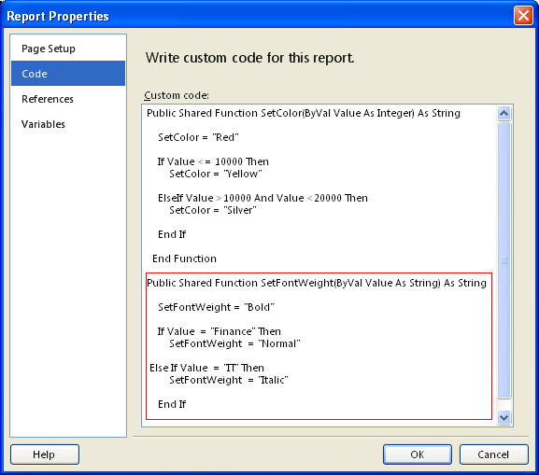

Then right click on Department Field -> Textbox properties - > Font - > Bold
And do the same thing for italic too
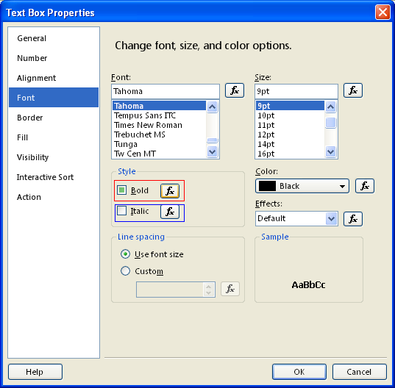

Write the code (Both for Bold & Italic)
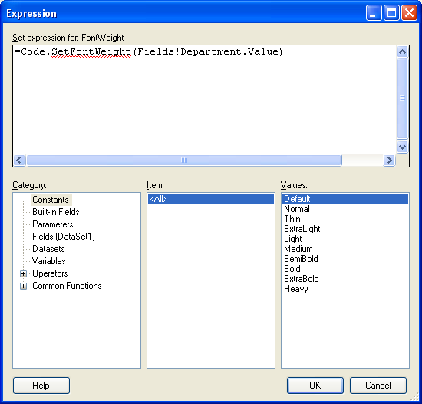

Save and preview
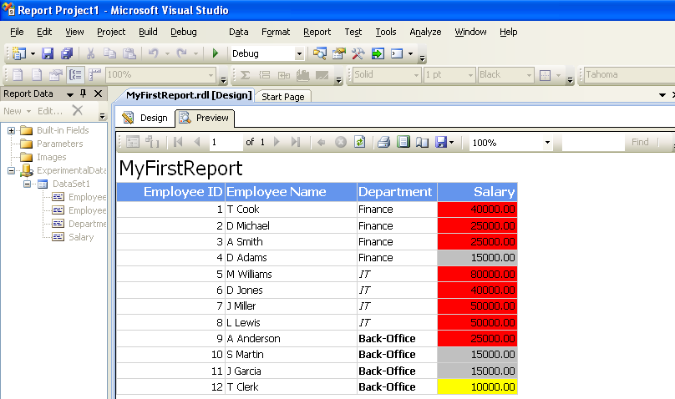

For alternate row color Based on EmployeeId value
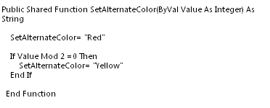
And write the code
